Lab 1

Name : Abdelrahman Mahmoud Kamal Mahmoud Nour
ID: 39

Lab 1

Program (a)
Set ALPHA equal to the integer portion of BETA / GAMMA.

Code:
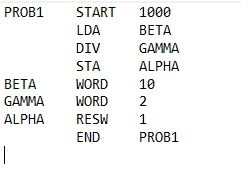

Sample Runs / Memory Contents:
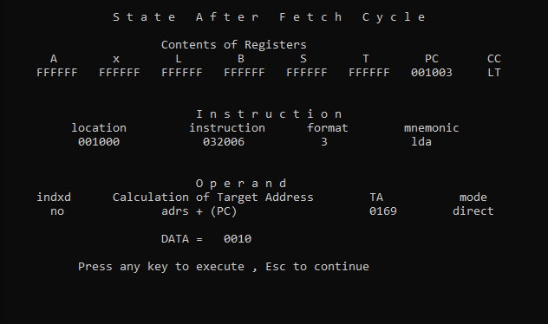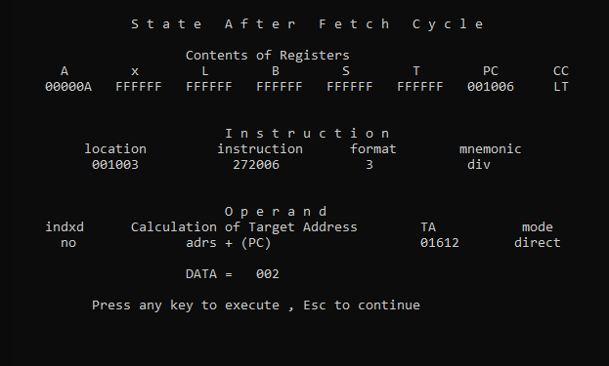
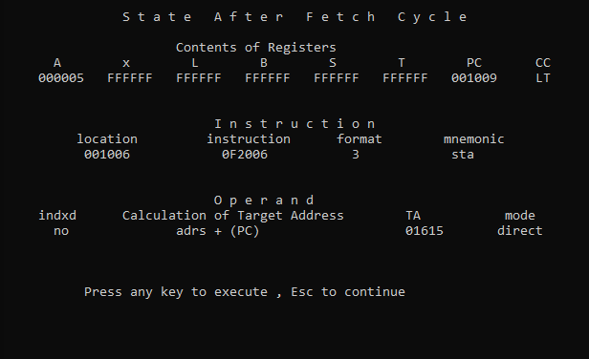

Program (B)
Set ALPHA equal to 4 * BETA + 3 * GAMMA

Code:

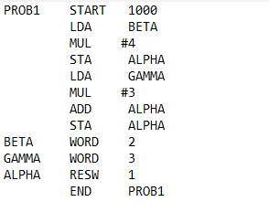

Assumptions:

Beta = 2, Gamma = 3 and their sum is equal to 17 which is stored in register A as 11 in hexadecimal

Sample Runs:
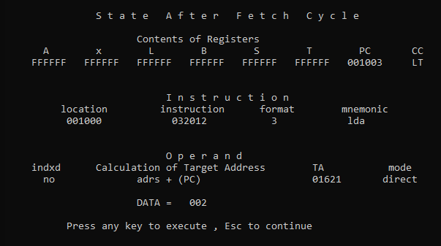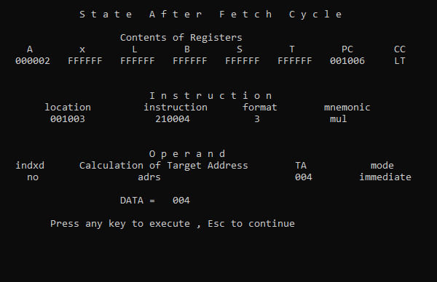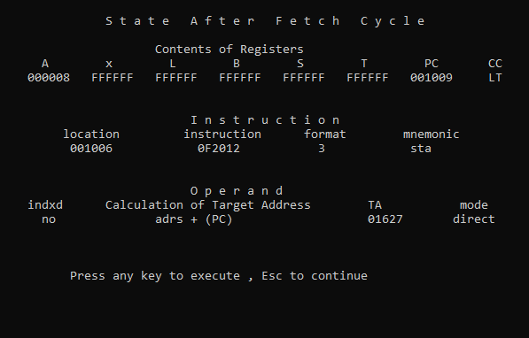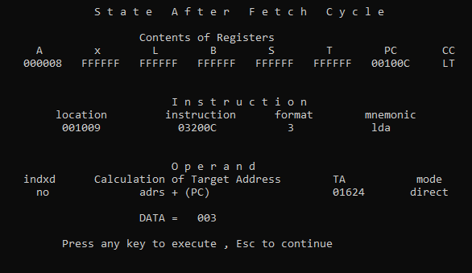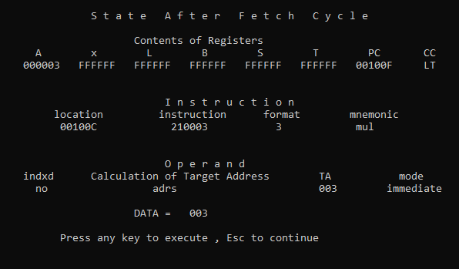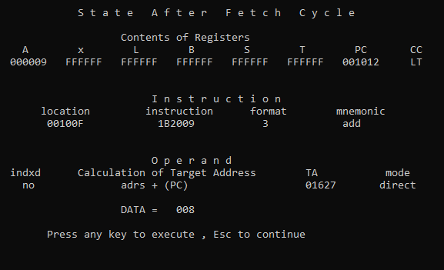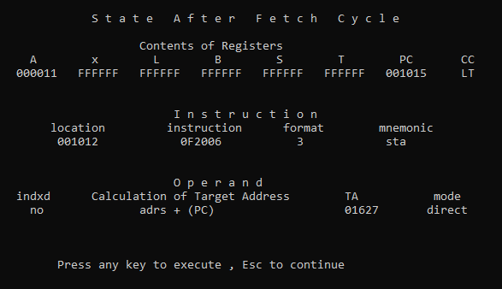

Program (C)..Clear a 100-byte string to all blanks

Code

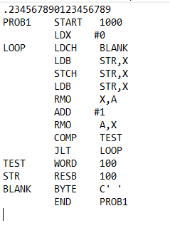
Assumptions:
The blank assumed here in this problem is a space character which is equal to ‘20’ in hexadecimal

Sample runs / Memory contents:
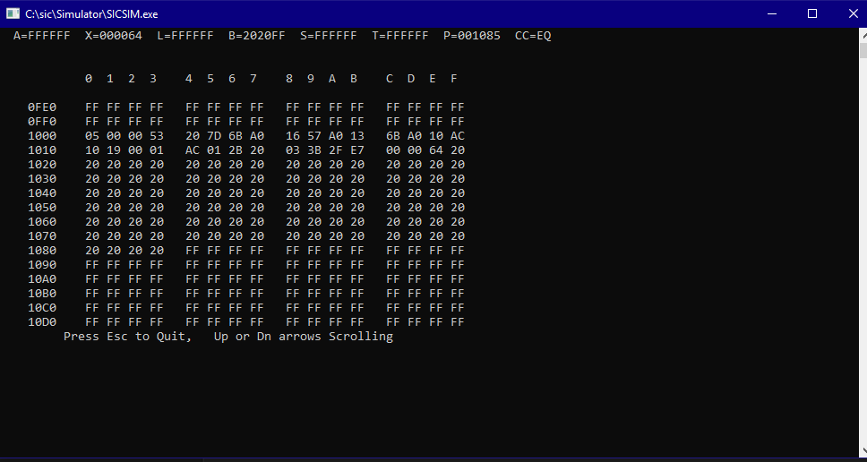

Program (D) SET elements of a 100-word array to 0

Code:
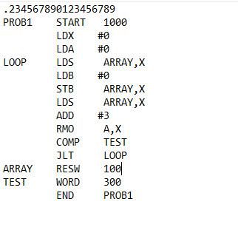
Sample Runs/Memory Contents:
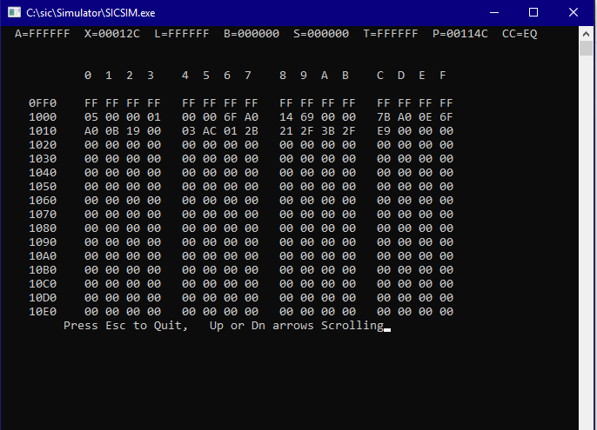
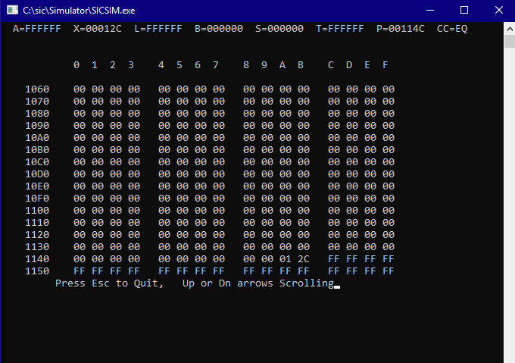

Program (e)
Read a string from device F3, calculate its length and store it in register A.
Code:
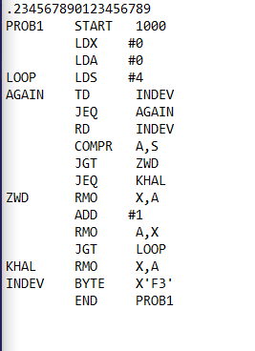
Assumptions:
The end of the file is marked by EOT char is equal to ‘04’ in hexadecimal, so at each byte, its hexadecimal value is compared to EOT character.

Sample Runs/ Memory Contents:
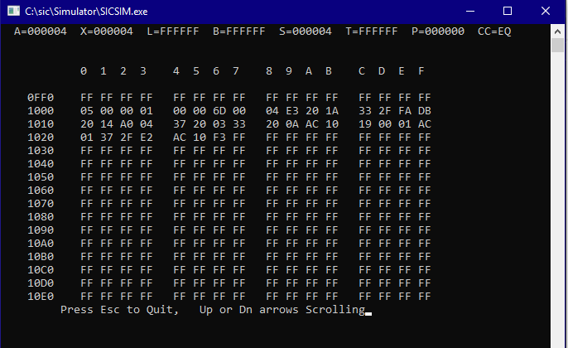

The contents of F3 in this sample run
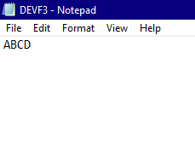

Program (F)
Read a two-digit number from device F3, convert this string to a number and store the number in register A

Code:
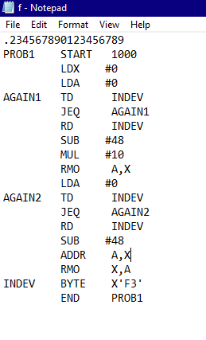

Sample Runs/Memory Contents:
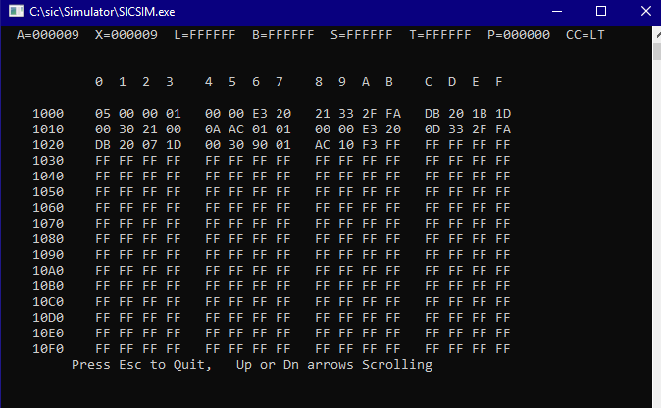
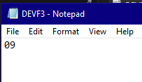

Another Sample Run
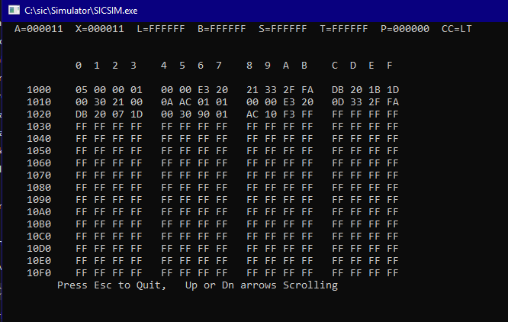
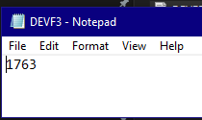
-17 is equal to 11 in the hexadecimal
-The program reads only first two digits as required .

